

Moving Head
PROFILE 1400 LED
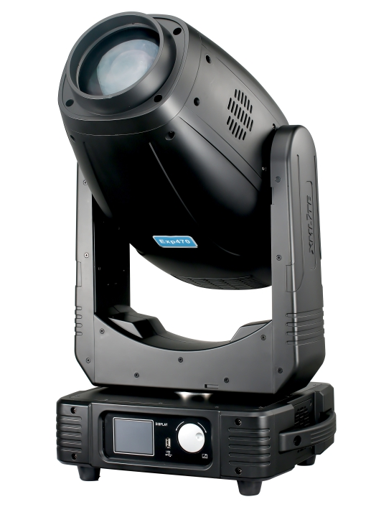

User manual


! Please read the manual before installing and using this lighting
Keep it for future reference

Thank you for purchasing our device.
We make every effort to ensure the best quality of our products and to meet your expectations.

If you have any remarks or comments, please share them with us.

We will be grateful for any suggestions that will help us make products that are even better and devices that satisfy your needs.

R&D Team

Table of contents
Statement 4
Production introduces 4
1. Fixture size 4
2. Part introduction 5
3. Safety information 6
4. Package 7
5. Install standard 8
6. Power supply 9
7. Lamp 9
8. Color wheel, gobo wheel 11
9. Control panel 12
10. CONTROL PANEL MENU OPERATE 12
11. DMX Channels 15
12. Clear and maintenance 19
13. Contact: 19

Statement
The product is good packing when ship out the factory. All users should strictly abide by the warnings and instructions stated in this manual, any damage and results due to misuse and the neglect of this operating manual will be excluded from the deal responsibility this manual will not informed in additionally if have technical changes.

Production introduces
Thank you for choosing this product. This is our latest development of intelligent, efficient products, beautiful and fluent, combined with the advanced technology of the stage lighting today. It has advanced international electronic control technology and excellent human nature chemical industry. The product is fully in conformity with the CE standard and the recipient country. The standard DMX512 signal mode is supported by the RDM protocol.
Production enforce standard IEC 60598-1:2014，IEC60598-2-17:2017.

Channels mode: 16/24CH;
Lamp: 470W White LED Engine ;
Life time：20000 hours;
Light Source Luminous Flux：30000；
power: AC110-240V,50/60Hz;
Total power: 700W;
Display: 2.8 inch screen display, can reverse 180°;
Color wheel: 7 fix colors+white+CMY+CTO.CT:2800-5600K
Fixed gobo : 8 gobo + white.
Rotation gobo: 6 gobo+ white, changeable;
Prism: 4 facet prism ,Frost function;
Beam angel : 6～42°;
Dimmer : 0-100% linear adjustment ;
Iris: Disphragm adjustable
Cut: 4 plates. Aftercut,the pattern can rotation 180°
connector can set dmx address with power and upgrade the software.
Position lock system: Magnetism position lock system
Pan : 540°; 8Bit/16Bit ;
Tilt : 270°; 8Bit/16Bit ;
IP Rate: IP20;

- Fixture size

Product size：404（L）×306（W）×736（H）mm
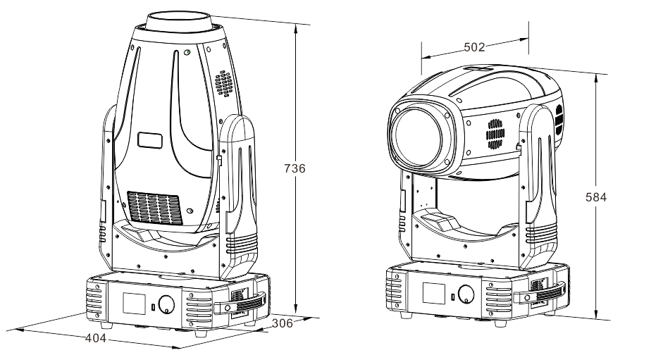
- Part introduction
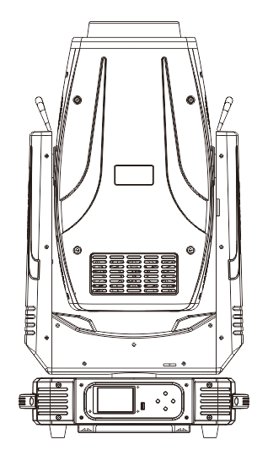
01 — Lens
02 — Body
03 — Arm
04 — Tilt Lock
05 — Pan Lock
06 — Light base
07 — Handle

03
01
02
06
05
04
07

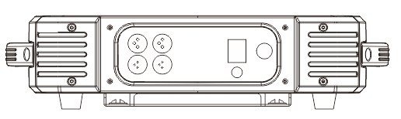
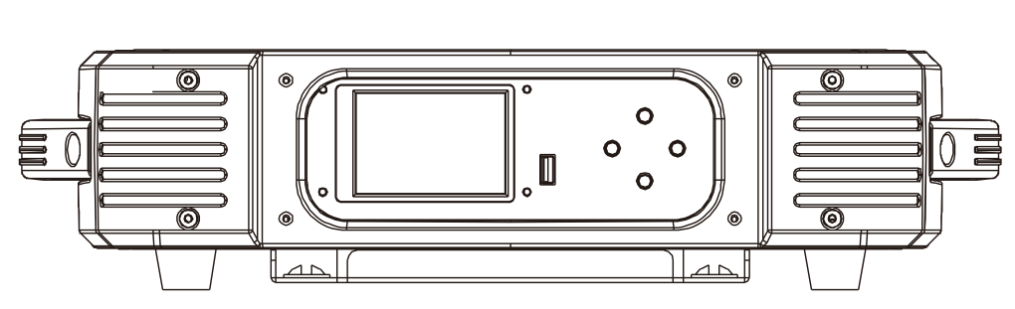
The structure of each part of the product is marked, and the main components of the lamps and lanterns are made up of the product names, so as to further understand the lamps and lanterns products.
01 —Control panel
02 — USB Port
03 — Button
01 — DMX In
02 — DMX Out
03 — Power switch
04 — Power in
05 — Fuse

01
03
04
02
05
01
02
03

The function of the product panel is introduced, the name of the part on the panel is indicated, and the functions and functions of each part are familiar.
- A description of a color wheel, a GOBO wheel, and so on
Color wheel: 7 fix color +white+CMY+CTO. CT:2800-5600K
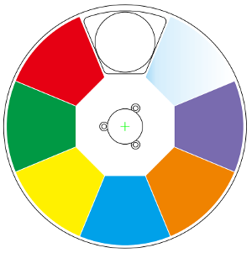
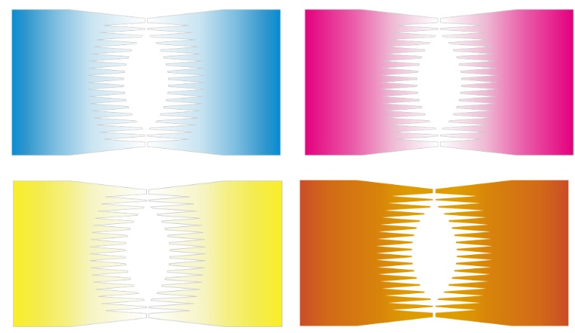

Fixed GOBO : 8 GOBO + white.Rich design, with the four prism better effect;
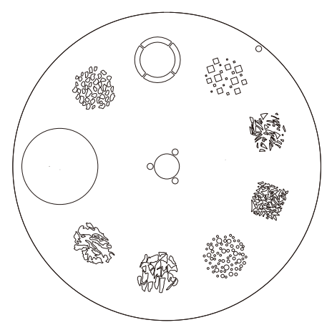
Rotation GOBO: 6 GOBO+ white.The rotation of the GOBO is smooth and the changeable is convenient.
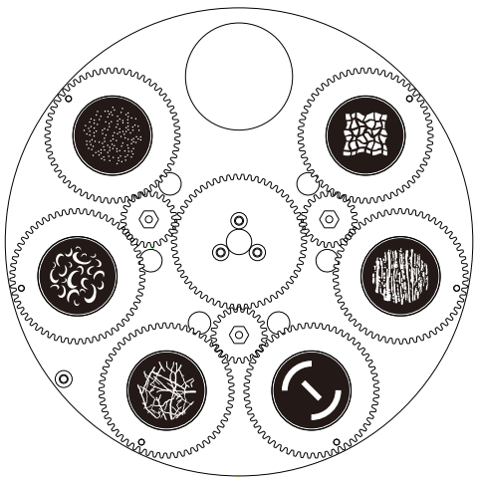
Equipped with a four prism, positive and negative rotation; linear atomization function;The prism with focused, rotated, enlarged and jitter, and the rotation speed can be adjusted.
- Safety information
Safety warning:
This product is only suitable for professional use, and does not apply to security for other purposes.
After you got the lights, please check the package whether have any damage caused by transportation. If there is any damage, do not use this fixture, and please contact the dealer or manufacturer as soon as possible. This product is only suitable for indoor, IP20 protection class. Lamps should be kept dry to avoid Moisture, overheating or dusty environment. Prevent lamps meet water or any other liquid. The use of this product should pay attention to: fire, heat, electric shock, ultraviolet radiation, the lamp to explode or shedding caused serious or fatal injury. Need to read the instructions before use energized or installing. Follow through the operation of security methods and pay attention to the warning signs on the specification and equipment. If you have any problem for how to safely operate the equipment. Please contact your dealer.
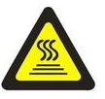
  - Anti-high temperature
ta =40°C
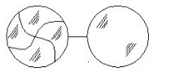
Please don’t use the equipment if the temperature above 40℃
  - Burst prevention
The lens should be changed if had damaged or any problems.
Don’t change the non-original manufacturer lens. Len size: ￠119mm×23mm
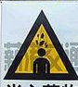
  - To prevent falling wounding

Please don’t move the package by one person only.
When Hang the fixture, please must verify that the facilities to be able to withstand the weight of the lamps at least 10 times more.
Please make sure the Mounting hardware is strong enough no any damage, and insurance for the safety rope as auxiliary security fixed in other facilities will need to verify before installation. Installing or removing the equipment, to make the pulley below the work location

  - UV protection and the bulb explosion

Prohibit straight viewpoint with exposed bulbs to avoid UV damage to the eyes;
Do not use the equipment without the lens screen and the lid;
The lens and the light head covers should be timely replaced if any damage to rupture
The Fixture should be used with the protection screen together.
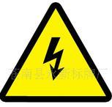
  - Prevention of electric shock

The electrical connection must only be carried out with corresponding qualifications;
Before installing, make sure you use the power voltage lamps must comply with the identified power, voltage and have an overload or leakage protection;
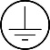
Each lamp must be properly grounded, installed in accordance with the relevant standards;
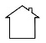
Cut off the power when stall or replace the lamp and the fuse;
Prohibit the use of a lightning storm or wet environment.
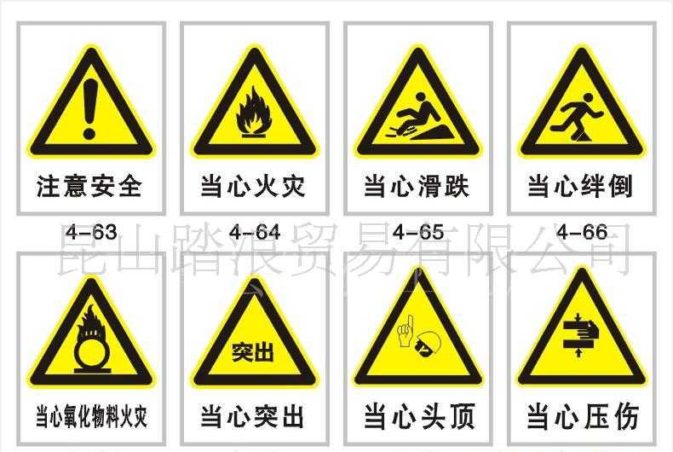
  - To prevent burning or fire
- The fixture can be mounted directly on the surface of ordinary combustible material.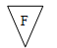
- Do not short-circuit temperature protection switch or fuse, use the specified type of fuse.
- The equipment must be installed away from inflammable and explosive materials.
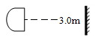
- The equipment should be projected range of 3 meters away objects and projectiles temperature less than 60 ° C;

- Fan or ventilation, at least in the range of 0.5 meters cannot be an obstacle.
- Do not place any object on the lens.
- Handling at least allow the device to cool for 20 minutes.
- Do not replace the non-original parts.
- Package
  - Attachment
HOT BEAM 2R packed with fly-case of one in one, two in one, or carton box. Attach follow accessory.
ACCESSORY
CONTENT | QUANTITY
USER MANUL | 1 piece
CLAMP (option) | 2 pcs
SIGNAL CABLE | 1 piece

  - Transport protect lock
To protect the light, there is a protect lock; During the transport, the lock will have closed keeping the item in safety state.

  - About pack stage
1. Before packed, make sure power is off, and wait for at least 20mins for cooling down.
2. Before cleaning the fixture, make sure X, Y axis protect lock closed.

3. After packed by plastic bag, high-lift the fixture with two handles besides the product. put the product into the fly-case up-side-down.
4. After packed the product, put the accessory into the accessory case, then closed and lock the fly-case.
5. Fly-case only up stacked two layers. Prohibited upside down
6. When packed with carton box, equipment should be put into the foam first, then set into a carton, pay attention to the vertical position.

  - Unpacking
Note: Before unpacking check the damage is whether due to the transportation or not, if you find any such damage, please do not use this item, and contact with the dealer or manufacturer as soon as possible.
- Open the fly-case, and discover the inside plastic bag.
- High-lift the product by two handles beside the bottom base and move it out.
- Before power on, make sure you have opened the X, Y axis lock!
- Install standard
  - Install lock
HOT BEAM 2R can be placed on the stage, or mounted in an arbitrary direction of the truss. Two fast locks system could fix the item easily.

  - Equipment fixed
  - Before installation must verify the fast lock is keep in good state, and can withstand at least 10 times the weight of product. Verify that the building can withstand at least 10 times of the total weight of the product and accessory equipment’s.
  - Fix the hang fixture into the hole, which located on the base of the price.
  - Seize handle of fasteners, clockwise rotate 1/4 turn and lock. Installed other one fastener
  - in the same method.
  - Using the safety cable which can withstand 10 times the weight of the equipment.
  - Make sure the X, Y protect locks are opened, verify that within 3 meters there is no combustibles.
WARNING
Fixture must use two fixing devices, and make sure the fixing device have locked! And only fully clockwise rotate 90 ° can lock the hang fixture! Do remember plus a safety rope, and do not connect the safety rope to plastic handle. It should be connected to the hole on the base!

  - Fixture connects

Attention! One product only can accept one input one output.
HOT BEAM 2R DMX cable include 3 contact pins:
Pin 1, FOR GROUND; Pin 2 connected to the negative polarity signal; The pin 3 connected to the positive polarity signal.

DMX512 cable must use the professional shielded twisted pair cable; standard loudspeaker cable is not reliable to control the long-range data. 24AWG cable is suitable for more than 300 meters long-distance signal transmission and must add\ DMX 512 signal amplifier.
Do not use two outputs to separate the connection, if separate a continuous connection to branch, DMX512 splitter is necessary.
If use the DMX512 splitter. At first connect DMX512 Splitter input terminal to controller, and then connected from the splitter output terminal to next device.
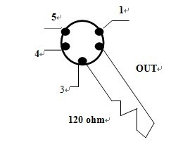
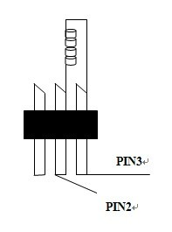
Do as above guide to connect other device, and finally coupled with terminal insertion as following:

- Power supply
  - Voltage, power, fuse specification

Input Voltage | Total Power | Frequency
110~240V | 150 W | 50/60HZ

  - Power protect
The equipment must be operated by professionals; Make sure that the voltage of power supply must be comply with the voltage identified on the lamp, and must have an overload or leakage electrical protection.
ATTENTION!

Factory has equipped the standard 3 pin plug socket. Connect the power supply as below table.
If lamp cable is damaged, replacement should be operated by factory or qualified staff. Any question, please contact professionals or talk to a qualified electrician.

Live wire(L) | Null(N) | Ground wire | 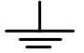
RED | BLUE | Yellow +Green
- Lamp
  - Lamp description

LAMP MODEL | POWER OF LAMP | LIFE/HOUR | COLOR TEMPERATURE
OSRAM SIRIUS HRI | 150 W | 4000 HOURS | 9300K

WARNING!
There is a safety hazard or damage if install similar bulb to reduce the risk of damage to light, do change the lamp before using time over 90% of lamp life.

  - Lamp replace
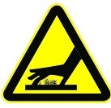
Attention! When replace the lamp is forbidden to touch lamp with bare hand, to avoid the greasy dirt stains filament. filament must be kept clean. Disconnect the power. Before replace lamp, fixture need 20 minutes for lamp cooling. Fasten the head with Y axis protect lock in 60 ° position.

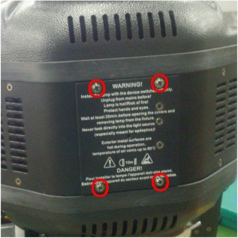
- Use cross screwdriver to open the light body cover

- After open the cover, you can see the lamp inside, please wait the lamp be cool after used but not touch it in hot status.

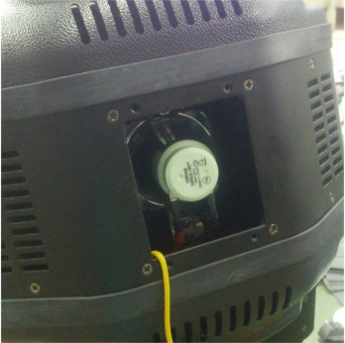

- One hand press the lamp holder, another hand hold the lamp and pull out the wires
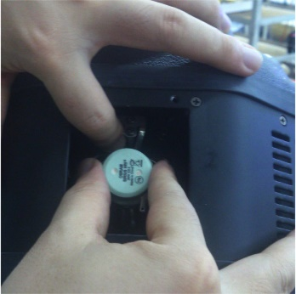

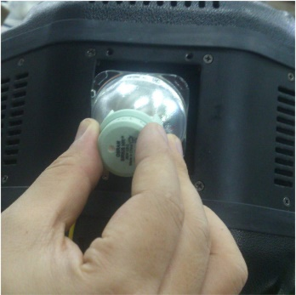


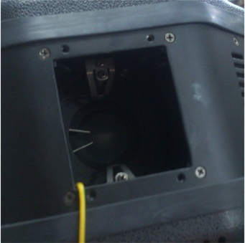
- after take apart the lamp, please check the inside glasses, clear it will make the light better effect

- installed the lamp after replaced.
- Color wheel, gobo wheel
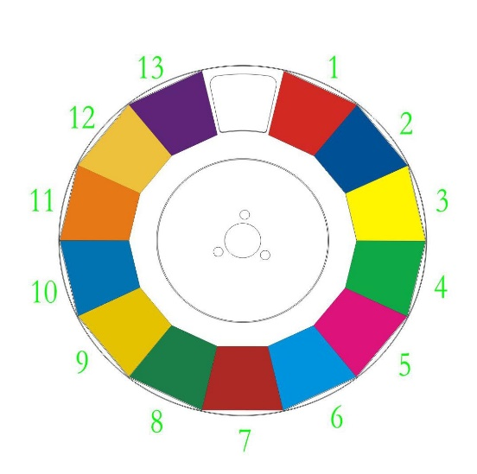

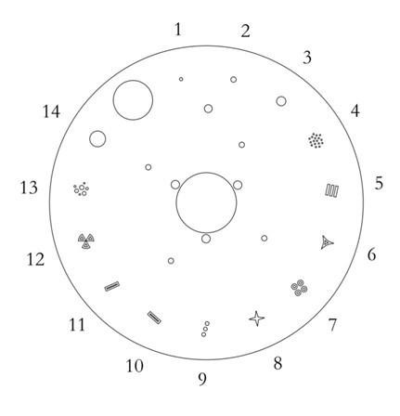
Fixed Gobo

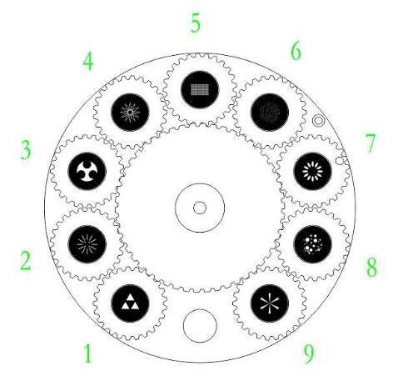
Rotation Gobo

MINIHOT BEAM Have 6 linear prism and 8 facet prism. With Focus . Rotation . Zoom . Shaking . Rotation speed changeable
- Control panel
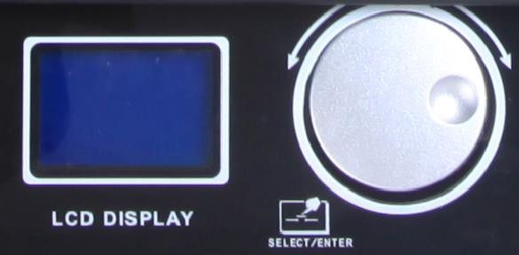
Display
Control wheel

Display: to display all information of fixture.
Control wheel: can turn right, left and enter.
turn left ： date increase
turn right ：date decrease
Press function ：enter

- CONTROL PANEL MENU OPERATE

Main Menu | Submenu 1 | Submenu 2 | Function SET | Function description
DMX Address |  |  | 001-512 | DMX Address number set
Display | "ShowReve" |  | "Natu" | Normal
Display | "ShowReve" |  | "Revl" | reverse 180°
Display | "Language" |  | "Chin" | Chinese 中文
Display | "Language" |  | "English" | English
Display | "BrigSett" |  | 000-255 | Brightness set
Display | "Backligh" |  | "60S " | Backlight close after delay  60S
Display | "Backligh" |  | "Ligh" | Backlight light always
Display | MenuBack" |  | 90S | Menu back to mainmenu  after delay 90S
Display | MenuBack" |  | "Off " | Menu back not automatic
Display | Backflah |  | open | Backlight blinking when no  dmx
Display | Backflah |  | off | Backlight not blinking when  no dmx
Display | "Return " |  | ▲ | return
"Feature " | "XY Setup" | "Xreverse" | "Off " | PAN SCAN Normal
"Feature " | "XY Setup" | "Xreverse" | "Open" | Pan Scan Reverse
"Feature " | "XY Setup" | "Yreverse" | "Off " | Tilt Scan normal
"Feature " | "XY Setup" | "Yreverse" | "Open" | Tilt Scan Reverse
"Feature " | "XY Setup" | "XY Speed" | "Fast" | PAN/TILT FAST
 |  |  |  | SPEED
 |  |  | "NORM" | PAN/TILT NORMAL
 |  |  | "Solw" | PAN/TILT SLOW
 |  | "X Angle" | "360 ", "360 " | Pan Angle 360°
 |  | "X Angle" | "540 ", "540 " | Pan Angel 540°
 |  | "X Angle" | "630 ", "630 " | Pan Angel 630°
 |  | "XY Fback" | "Off " | PAN/TILT optical sensor testing off
 |  | "XY Fback" | "Open" | PAN/TILT optical sensor testing on
 |  | Return | ▲ | Return
 | "Shortcut" |  | "Off " | Shortcust off for colors and gobos
 | "Shortcut" |  | "Open" | Shortcust open for colors and gobos
 | "FullColr" |  | "Off " | half color function
 | "FullColr" |  | "Open" | full color function
 | "ChanMode" |  | "Smal" | Simplify mode
 | "ChanMode" |  | "Stan" | Standard mode
 | "ReceMode" |  | "DMX " | Accept DMX
 | "ReceMode" |  | "Wire" | Accept Wireless
 | "ReceMode" |  | "Auto" | AutoRun
 | "RunMode " |  | "Slve" | Accept other signal control
 | "RunMode " |  | "Musc" | Sound active
 | "RunMode " |  | "Auto" | Inside program Run automatically
 | "SigClear" |  | "Off " | keep signal data
 | "SigClear" |  | "Open" | clear signal data
 | DMX Reset |  | Off | Dmx reset not accept
 | DMX Reset |  | Open | Dmx reset accept
 | Return |  | ▲ | Return
"LampSett" | "Default " |  | "Wink" | Lamp off
"LampSett" | "Default " |  | "Ilum" | Lamp on
"LampSett" | "Control " |  | "Wink" | Lamp off by manual
"LampSett" | "Control " |  | "Ilum" | lamp on by manual
"LampSett" | "DmxLamp " |  | "Off " | Close other signal control the lamp
"LampSett" | "DmxLamp " |  | "Open" | Open other signal control the lamp
"LampSett" |  |  | 0000-9999 | Lamp used time recorded
 | "LampTime"
 | "ClearTim" |  | ★ | Password input Enter
 | "ClearTim" |  | "Ilum" | Clear Lamp time
 | "LampStat" |  | "Wink" | Lamp off
 | "LampStat" |  | "Ilum" | Lamp on
 | Return |  | ▲ | Return
"InfoSee " | "WorkHour  " |  | 0000-9999 | working hours memo for connect power
"InfoSee " | "Times  " |  | 0000-9999 | Open times memo
"InfoSee " | "Fan1Rota" |  | 0000-9999 | Fan rotation speed 1
"InfoSee " | "Fan2Rota" |  | 0000-9999 | Fan rotation speed 2
"InfoSee " | "Version " |  | XMOA | Version
"InfoSee " | Spare time |  | No limit | No limit time
"InfoSee " | Spare cut |  | No limit | No limit times
"InfoSee " | Return |  | ▲ | Return
"Control " |  |  | Chan 00-Chan  40 | Control the Channels
"AssiTool" | "Factory " |  | ★ | Password input Enter
"AssiTool" |  |  | "Fold" | Recover Factory set
"AssiTool" |  |  | "Save" | Save factory set
"AssiTool" | "Defaults" |  | ★ | Password input Enter
"AssiTool" |  |  | "Fold" | Recover to default
"AssiTool" | Redress |  | ★ | Password input enter
"AssiTool" |  |  | Reset01-10 | Set the motors
"AssiTool" | Chdefine |  | Color wheel  Rotation 001 | Channels set by define
"AssiTool" |  |  | 000……040 | Channels set by define
"AssiTool" | "Brightne" |  | ★ | Password input Enter
"AssiTool" |  | "TimeLimi" | 0000-9999 | Open fixture time limit
"AssiTool" |  | "TimsLimi" | 0000-9999 | fixture times limit
"AssiTool" |  | TimeCLEA | clear | Clear the time of used
"AssiTool" |  | CutClea | clear | Clear the times of used
"AssiTool" |  | "Passwor1" | 000-255 | Revise password 1
"AssiTool" |  | "Passwor2" | 000-255 | Revise password 2
"AssiTool" |  | "Passwor3" | 000-255 | Revise password 3
"AssiTool" |  | "Passwor4" | 000-255 | Revise password 4
"AssiTool" |  | "X Drivin" | 000-255 | pan main drive gear
"AssiTool" |  | "X Driven" | 000-255 | Pan slave drive gear
 |  | "Y Drivin" | 000-255 | Tilt main drive gear
 |  | "Y Driven" | 000-255 | Tilt slave drive gear
 |  | "LampPowe" | "Off " | Ballast earthed
 |  |  | "total 5V", "Open" | Ballast 5V
 |  | "YAngle " | 000-255 | Tilt angel rotation set
 |  | "Return " | 000-255 | return
 | "Checksum  " | 01-10" |  | Check Cabrilate data
 | Return |  | ▲ | Return
CHANLEVE |  |  | Chan1..140 | Show the dmx address
MotorRst |  |  | Color...focus | Display the status
MotorRst | Return |  | ▲
All Reset'' |  |  | "Annu" | Cancel
 |  |  | "Exec" | Reset
XY Rst | PAN/tilt  RESET |  | "Annu" | Cancel
XY Rst | PAN/tilt  RESET |  | "Exec" | Reset
EffecRst | Effect reset |  | "Annu" | Cancel
EffecRst | Effect reset |  | "Exec" | Reset
"ExitMenu" |  |  | ▲ | Exit

- DMX Channels
MODE 1 | MODE 2 | DMX Value | Description
1 | 1 | 0－255 | Pan
2 | * | 0－255 | Pan Fine
3 | 2 | 0－255 | Tilt
4 | * | 0－255 | Tilt Fine
5 | 3 | 0－255 | Pan/Tilt speed
6 | 4 |  | Micro
6 | 4 | 0－19 | Empty
6 | 4 | 20－24 | Energy-saving mode（230W）
6 | 4 | 25－129 | Empty
6 | 4 | 130－139 | Lamp on by dmx
 |  | 140－149 | PAN/TILT reset
 |  | 150－159 | Empty
 |  | 160－169 | Small motors reset
 |  | 170－199 | empty
 |  | 200－209 | Whole unit reset
 |  | 210－229 | empty
 |  | 230－239 | Lamp off by dmx
 |  | 240－255 | empty
7 | 5 |  | Colors
7 | 5 | 0－8 | white
7 | 5 | 9－17 | Deep Red
7 | 5 | 18－26 | Deep blue
7 | 5 | 27－36 | Yellow
7 | 5 | 37－45 | Green
7 | 5 | 46－54 | Magenta
7 | 5 | 55－63 | Azure
7 | 5 | 64－72 | Red
7 | 5 | 73－81 | Dark green
7 | 5 | 82－90 | Amber
7 | 5 | 91－100 | blue
7 | 5 | 101－109 | orange
7 | 5 | 110－118 | CTO
7 | 5 | 119－127 | UV
7 | 5 | 128－129 | white
7 | 5 | Positioning
 |  | 130－134 | Deep Red
 |  | 135－138 | Deep blue
 |  | 139－143 | Yellow
 |  | 144－147 | Green
 |  | 148－152 | Magenta
 |  | 153－157 | Azure
 |  | 158－161 | Red
 |  | 162－166 | Dark green
 |  | 167－171 | Amber
 |  | 172－176 | blue
 |  | 177－180 | orange
 |  | 181－185 | CTO
 |  | 186－189 | UV
 |  | 190－215 | Forwards rainbow ,speed down
 |  | 216－217 | No rotation
 |  | 218-243 | Backwards rainbow, speed up
 |  | 244-255 | Random color
8 | * |  | empty
9 | 6 |  | empty
 | 7 |  | Static gobo
10 |  | 0－3 | empty
10 |  | 4－9 | Gobo 1
10 |  | 10－15 | Gobo 2
10 |  | 16－21 | Gobo 3
10 |  | 22－27 | Gobo 4
10 |  | 28－33 | Gobo 5
10 |  | 34－39 | Gobo 6
10 |  | 40－45 | Gobo 7
10 |  | 46－51 | Gobo 8
10 |  | 52－57 | Gobo 9
10 |  | 58－63 | Gobo 10
10 |  | 64－69 | Small beam 1
10 |  | 70－75 | Small beam 2
10 |  | 76－87 | Small beam 3
10 |  |  | Gobo shaking from slow to fast
10 |  | 88－95 | shaking
10 |  | 96－103 | Gobo 2
10 |  | 104－111 | Gobo 3
10 |  | 112－119 | Gobo 4
10 |  | 120－127 | Gobo 5
10 |  | 128－135 | Gobo 6
10 |  | 136－143 | Gobo 7
10 |  | 144－151 | Gobo 8
10 |  | 152－159 | Gobo 9
10 |  | 160－167 | Gobo 10
 |  | 168－175 | Small beam 1
 |  | 176－183 | Small beam 2
 |  | 184－199 | Small beam 3
 |  | 200－255 | Static gobo run from slow to fast
11 | 8 |  | Rotate gobo
11 | 8 | 0－8 | empty
11 | 8 | 9－17 | Gobo 1
11 | 8 | 18－26 | Gobo 2
11 | 8 | 27－35 | Gobo 3
11 | 8 | 36－44 | Gobo 4
11 | 8 | 45－53 | Gobo 5
11 | 8 | 54－62 | Gobo 6
 |  | 63－71 | Gobo 7
 |  | 72－80 | Gobo 8
 |  | 81－89 | Gobo 9
 |  |  | Gobo shaking from slow to fast
 |  | 90－97 | Shaking ,from slow to fast
 |  | 98－106 | Gobo 2
 |  | 107－115 | Gobo 3
 |  | 116－124 | Gobo 4
 |  | 125－133 | Gobo 5
 |  | 134－142 | Gobo 6
 |  | 143－151 | Gobo 7
 |  | 152－160 | Gobo 8
 |  | 161－169 | Gobo 9
 |  | 171－179 | Gobo 9 not move
 |  | 180－217 | Run from fast to slow
 |  | 218－255 | Run from slow to fast
12 | 9 |  | Gobo rotation
12 | 9 | 0－127 | index
12 | 9 | 128－177 | Run from slow to fast in anti clockwise
12 | 9 | 178－203 | stop
12 | 9 | 204－255 | Run from fast to slow in clockwise
13 | * | 0－255 | empty
14 | 10 |  | prism
14 | 10 | 0－19 | empty
14 | 10 | 20－75 | 6 linear prism
14 | 10 | 76－255 | 8 facet prism
15 | 11 |  | Prism rotation
15 | 11 | 0－127 | index
15 | 11 | 128－191 | Run from fast to slow in clockwise
15 | 11 | 192－194 | empty
15 | 11 | 195－255 | Run from slow to fast in anti clockwise
16 | 12 |  | Frost
16 | 12 | 0－64 | empty
16 | 12 | 65－255 | linear frost
17 | 13 |  | zoom
 |  | 0－255 | Linear zoom
18 | * | 0－255 | Zoom fine
19 | 14 | 0－255 | focus
20 | * | 0－255 | Zoom fine
21 | * | 0－255 | empty
22 | 15 |  | strobe
22 | 15 | 0－31 | Strobe close
22 | 15 | 32－63 | No Strobe
22 | 15 | 64－95 | Strobe from slow to fast
22 | 15 | 96－127 | No Strobe
22 | 15 | 128－143 | Fast to slow,slow close fast open
22 | 15 | 144－159 | Slow to fast,fast open slow close
22 | 15 | 160－191 | Strobe open
22 | 15 | 192－223 | Random strobe from slow to fast
22 | 15 | 224－255 | No strobe
23 | 16 |  | dimmer
23 | 16 | 0－255 | Linear dimmer
24 | * |  | empty

- Clear and maintenance
Warning: Please make sure cut off the power before open the covers.
(Kind Remind: Non-Professional don’t do this)
- Cut off the power supply, cool down the lamp and open the covers.
- Using vacuum or pressure blows gently blow any dust and floating structures.

Contact:
Please check who is our dealer in your country at our website

www.kudux.com

or write direct to us by email: office@kudux.com

